7.2 Improve DAX performance

Key Points
There are a number of methods you can use for improving DAX performance, we will look at using DAX Studio.

DAX Studio use cases:
- Use the VertiPaq Analyzer to understand the size of your semantic model (as well as individual tables and columns, within the model).

- Bring Power BI Desktop Performance Analyzer data into DAX Studio for further analysis.

- Trace analysis:

- All Queries trace: captures query events from client tools (like Power BI)

- Query Plan trace: query plan trace events from a SSAS Tabular server

- Server Timing trace

- Analyze DAX performance using Query Profiling

- Write, execute, and debug DAX queries (need to be manually copied over to Power BI Desktop, as DAX Studio is 'Read-Only').

- Charting and Pivot table for visualization

DAX Studio for DAX performance improvements
- You can load Power BI Performance Analyzer data into DAX Studio for further analysis

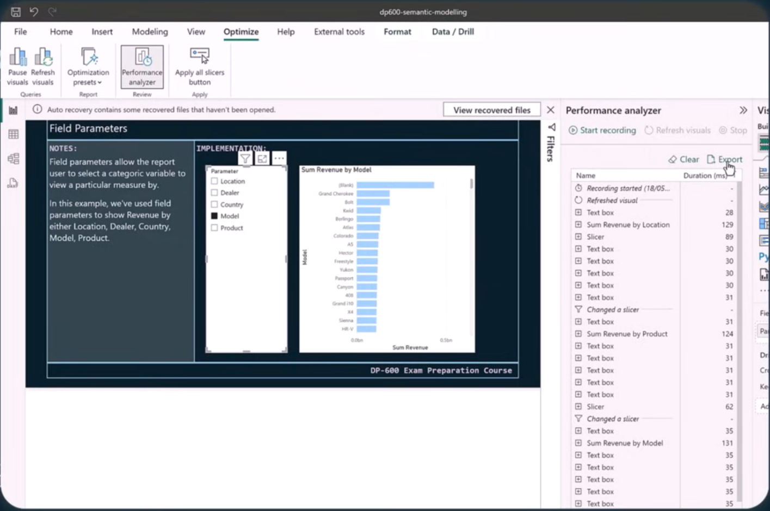
- Better filtering and sorting than in Power BI Desktop, plus you can view the queries behind each visual load.

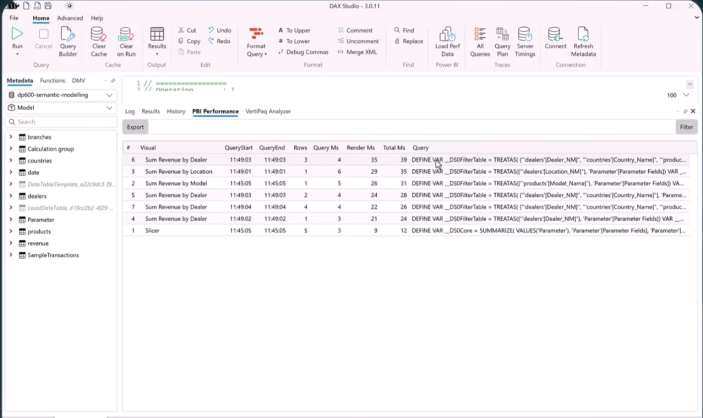

- Use View Metrics to look at the VertiPaq Analyzer:

- Review Table and Column Sizes (and look for reasons WHY - cardinality, datatypes, other).

- Look for referential integrity violations (mismatch in unique keys on two sides of a relationships).
